# PDF archival testing

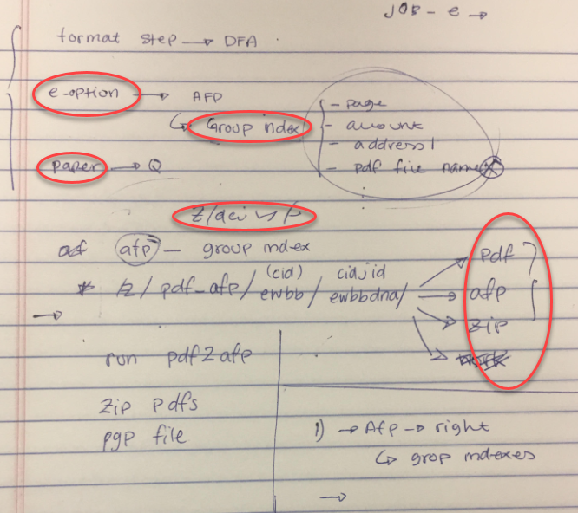

1. Check and run parallel report based on the Parallel ID from the JEF
2. Go to the : cd /z/daily/ewbbdna/

-rw-rw-rw- 1 oper1 opers 1550234 Oct 8 16:56 ewbbdn001.afp

-rw-rw-rw- 1 oper1 opers 3472229 Oct 8 16:57 ewbbdna1054.2o1.afp

-rw-rw-rw- 1 oper1 opers 50796 Oct 8 16:57 ewbbdna1055.2oz.afp

-rw-rw-rw- 1 oper1 opers 4518 Oct 8 16:57 ewbbdna1055.pdf.afp

-rw-rw-rw- 1 oper1 opers 80412 Oct 8 16:57 ewbbdna1055.fgn.afp

-rw-rw-rw- 1 oper1 opers 2355 Oct 8 16:57 ewbbdna105.is.afp

1. Copy “ewbbdn001.afp” to local folder

>>> cp ewbbdn001.afp /d/iss/IgorK/{CID}

Open copied .afp file in Papyrus to verify

1. Open shell script

vi /home/test/master/ewbb_dna_process.sh

and search for the



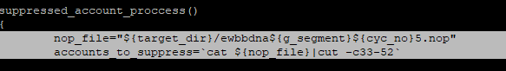

1. Go to all pdf archival path

cd /z/pdf_afp/ewbb/ewbbdna/

1. List of the

ls -ltr afp/

Gives us total 1516

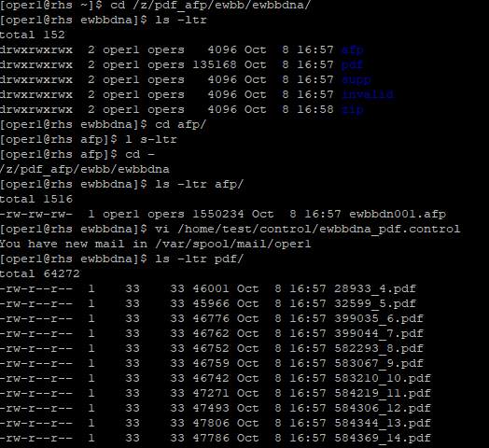

1. Compare total by finding the index file by using

cd /z/pdf_afp/ewbb/ewbbdna/

ls -ltr pdf/

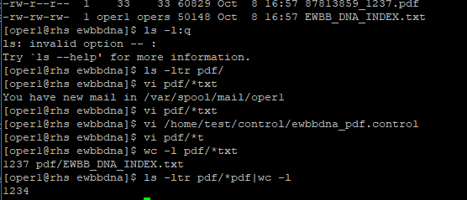

1. The index file (txt) has total of 1237 records

Check for the number of pdf’s has 1234 records

>>> number of records in index file >> should match number of records in pdf folder

NOTE:

In above shown scenario “3” records are different and as they are posted on the e-Site

Client doesn’t want to pdf archived for eStatement posted

>>> If there is different >>>> Need to show to Developer